- THE WORK OF ART
- IMPORTANCE State the importance of the work in relation to the existing MFAH collections, being candid about its strengths and weaknesses, its rarity of quality, technique, type, etc.

Since the early 1990s Mexican photographer Alejandro Cartagena has developed a dynamic body of work exploring social, urban, and environmental issues, largely through the lens of his contemporary Mexican experience. He is widely recognized not only as an astute and thoughtful photographer, but also as one of the most prolific self-publishers working in the photobook arena today. Virtually all of his bodies of works are envisioned as book projects from the outset. For Cartagena, printing, typography, graphic design, sequencing, and binding are all essential elements of his artistic production, whether incorporating photographs of his own or those that he has mined from external archives.

Over the course of the past decade Cartagena has addressed many of the most pressing issues in his home city of Monterrey, Mexico—issues that are echoed in communities across North America. Each of these projects has culminated in a self-published photobook addressing subjects as diverse and complex as the impact of suburban sprawl (Suburbia Mexicana, 2011), labor migration (Carpoolers, 2014), the war on drugs (Before the War, 2015), the environmental impact of development on rivers (Rivers of Power, 2016), the social and political landscape in America (Santa Barbara Shame on US, 2017), the construction of reality through photography (Los Sumergidos, 2018), the marketing of politicians in the age of social media (Enrique, 2018), and the challenges inherent in public transportation systems (Suburban Bus, 2021).

On offer here is the photographer’s complete inventory of 87 maquettes and 8 posters for his 25 photographic book projects during the period from 2011-2021. Maquettes, also known as models or dummies, are preliminary works that capture the development of a book at a particular stage before reaching its final published form. Cartagena’s practice for book design often involves multiple stages of development, yielding a rich array of documentary evidence about his practices and processes. These maquettes document not only physical alterations that take place over the course of each production such as changes in graphic design, typography, paper selection, color balance, image density, and binding type, but they also capture critical shifts in concept, narrative, and sequence that can radically alter a project. More importantly, they provide us with the rare opportunity to peer into the mind of an artist and gain insight into the creative process as ideas shift and fluctuate before becoming fully realized in their final form.

This grouping of maquettes illustrates the evolution of the conceptual, aesthetic, and formal development of each project as well as of Cartagena’s overarching practice. Additionally, they underscore the shifts in publishing models from long-accepted practices to more recent digital publishing modes.

Born in 1977 (Santo Domingo, Dominican Republic), Cartagena lives and works in Monterrey, Mexico. His work has been exhibited internationally in more than 50 group and individual exhibitions and is in the collections of numerous museums including the Museum of Fine Arts, Houston, San Francisco MOMA, The J. Paul Getty Museum, the George Eastman Museum, and the Santa Barbara Museum of Art, The Museum of Contemporary Photography in Chicago, and the Portland Museum of Art among others.

Cartagena’s publications have been shortlisted or won numerous awards, including the Rencontres d’Arles Book Award, the Best Photography Book Award at PHoto ESPAÑA, and the KASSEL PHOTOBOOK AWARD. Most recently, Cartagena was shortlisted for the Deutsche Börse Photography Foundation Prize in 2021.

Cartagena has received several awards including the international Photolucida Critical Mass Book Award, the Street Photography Award in London Photo Festival, the Lente Latino Award in Chile, the Premio IILA-FotoGrafia Award in Rome and the Salon de la Fotografia of Fototeca de Nuevo Leon in Mexico among others. He has been named an International Discoveries of the FotoFest festival, a FOAM magazine TALENT and an Emerging photographer of PDN magazine. He has also been a finalist for the Aperture Portfolio Award and has been nominated for the Santa Fe Photography Prize, the Prix Pictet Prize, the Photoespaña Descubrimientos Award and the FOAM Paul Huff Award. His work has been published internationally in magazines and newspapers such as Newsweek, Nowness, Domus, the Financial Times, The New York Times, Le Monde, Stern, PDN, The New Yorker, and Wallpaper among others.

- DESCRIPTION Provide a complete description of the object and mention any added attachments, missing parts, etc.

All 87 maquettes and 8 posters produced in conjunction with Cartagena’s 25 book projects are listed below. This constitutes the complete pre-publication output by the photographer.

Suburbia Mexicana, 2011 (2 maquettes)
Carpoolers, 1st Edition, 2014 (4 maquette; 1 poster)
Headshots, 2015 (1 maquette)
Before the War, 2015 (1 maquette; 1 poster)
Carpoolers, 2nd Edition, 2016 (3 maquettes)
What We Fight For, 2016 (4 groupings of unbound pages; 4 posters)
Rivers of Power, 2016 (5 maquettes)
Santa Barbara Return Jobs Back to US, 2016 (4 maquettes)
A Guide to Infrastructure and Corruption, 2017 (2 maquettes; 2 epilogues)
Santa Barbara Shame on US, 2017 (4 maquettes)
A Small Make Believe Neighborhood, 2017 (2 maquettes)
Enrique, 2018 (1 maquette)
Los Sumergidos, 2018 (7 maquettes)
Carpoolers, 3rd Edition, 2019 (2 maquettes; 2 posters)
We Love Our Employees, 2019 (2 maquettes)
Santa Barbara Save US, 2020 (4 maquettes)
El Casting, 2020 (1 maquette)
A Small Guide to Homeownership, 2020 (1 grouping of loose unbound pages)
Insurrection Nation, 2021 (1 maquette)
Suburban Bus, 2021 (5 maquettes)
Car Show, 2021 (4 maquettes)
Fossiles, 2021 (10 maquettes)
Lost Rivers, 2021 (2 maquettes)
Love and Politics, 2021 (8 maquettes)
Roma Roma, 2021 (7 maquettes)

More fulsome details on each of the maquettes are included in the attachments. Additionally, an expanded set of images for each book project is available on the artist’s website.

INSCRIPTIONS Transcribe any inscriptions.

MARKS Describe any marks.

- STYLE Describe the style of the work and relate it to the appropriate artist, school, period, etc.

D. ICONOGRAPHIC Does the iconographic treatment follow an established program or is it unusual?
TREATMENT

E. FUNCTION State the function of the work. Was it part of a greater whole or an independent work?

This constitutes the complete inventory of the artist’s pre-publication output and documents his changing vision as each project develops.

F. COMPARABLE Discuss and illustrate two or three works of art that make the best comparisons with the recommended
WORKS purchase. Indicate what distinctive qualities the recommended purchase has in relation to these comparative works in terms of style, technique, condition, documentation, etc.

The Museum owns a number of significant photographic maquettes that reflect our prior commitment to this area of collecting. Among the most significant are those produced by Man Ray, Robert Frank, and Alec Soth—each among the most respected photographers and bookmakers of his generation. The group of maquettes by Cartagena would complement these works by highlighting contemporary bookmaking practices.

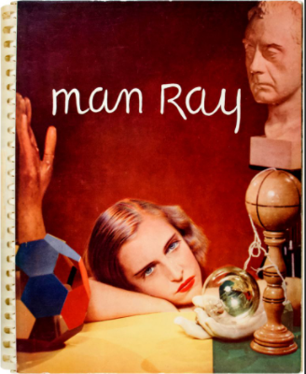
Photographs by Man Ray: 1920, Paris, 1934 [proof collection] Hartford, CT: James Thrall Soby, 1933–34.
Vol. 1, text proof 1920–33; vol. 2, text proof 1920–34; vol. 3, final proof 1920–34. Book maquette. The Manfred Heiting Book Collection, museum purchase funded by the Caroline Wiess Law Accessions Endowment Fund, LIB.124.

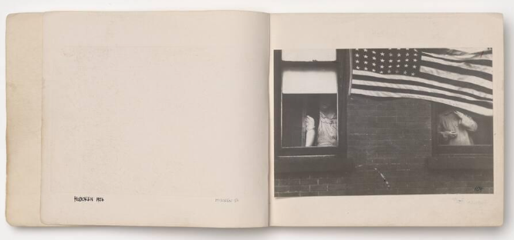
Robert Frank. The Americans, 1958. Book maquette. The Target Collection of American Photography, museum purchase funded by Target Stores, 85.457.

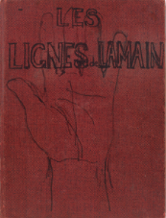
Robert Frank. Les Lignes de la Main (The Lines of My Hand) [Maquette], 1971. Book maquette. Museum purchase funded by Gay Block, 89.118.

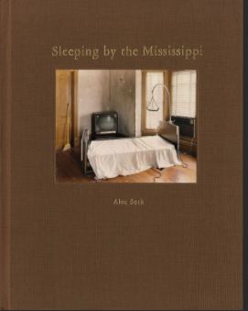
Alex Soth. Sleeping by the Misssissippi [sic] [S.l.]: A. Soth, 2003. Book maquette. Hirsch Library, gift of Alec Soth. LIB.130.

Additionally, the Museum owns 3 works by Cartagena:

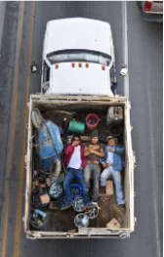
Alejandro Cartagena. Carpoolers #3, 2012. Inkjet print. Museum purchase funded by Judy Nyquist in honor of Scott Nyquist, 2013.52.

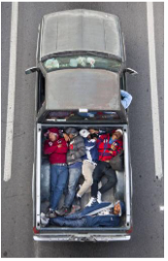
Alejandro Cartagena. Carpoolers #21, 2012. Inkjet print. Museum purchase funded by Joan Morgenstern, 2013.53.

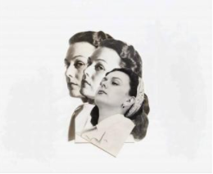

Alejandro Cartagena. We are #17, 2020. Gelatin silver print. Museum purchase funded by the Photography Subcommittee, 2020.162.

G. EXHIBITION Present plans for exhibiting and housing the object. Will this object require any special storage or
AND HOUSING crating needs?

No immediate plans, though the materials are excellent candidates for future installations in the Kinder
Building’s photography galleries as well as the Hirsch Library.

H. PUBLISHING Present plans for publishing the object, in print and/or online:
PLANS

- CONDITION State any issues of condition that should be taken into account prior to the work’s acquisition. A conservator’s detailed analysis and results of technical investigation should be appended to this form. Where appropriate, conservators must comment on evidence of burial.

- PROVENANCE
  - Give the history of the object, all that is known of its provenance with documentation. Include any hearsay evidence or traditional provenance, with source, and attach all relevant correspondence with the dealer or previous owners.

All materials come direct from the artist’s studio.

B. ANCIENT This work is NOT considered “ancient” in the field
BURIED This is NOT the type of work likely to have been buried or discovered at an archaeological site.

- REFERENCES
A. List all published references and emphasize those of the most relevance.

B. EXPERT ADVICE Note any expert advice sought or volunteered from outside the MFAH.

C. BIBLIOGRAPHY

D. CATALOGUE RAISONNÉ

E. EXHIBITION HISTORY

V. FINANCIAL CONSIDERATIONS
  - PRICE Price (in local currency and approximate conversion as of date of this report):

$85,000

  - NEGOTIATIONS Tell how long you have known of the work and give a history of negotiations.

Discussions with the artist and his gallery have been underway since March 2021.

  - RESTRICTIONS AND BARGAINING State any conditions attached to the purchase and chances for bargaining.

  - MARKET PRICES Give recent market prices for comparable works of art.

Given the unique nature of these materials there are no comparables for such a grouping.

  - EXCHANGE If the object is to be acquired by an exchange, specify MFAH object(s) involved, including accession number(s), valuation and status of deaccessioning.

  - ADDITIONAL Detail of additional expenses. Specify anticipated additional expenses (transportation, insurance,
EXPENSES import fees, storage, other). Include the estimated amount if MFAH is to pay.

  - FABRICATION If this artwork requires any additional exceptional fabrication for display, itemize all anticipated EXPENSES equipment and labor costs. How would these costs be underwritten?

  - FUNDING Detail of funding sources. State the name of the fund(s), gift(s), and/or pledges to be applied if you SOURCES recommend that such sources be used.

Caroline Wiess Law Accessions Endowment Fund, Photography Book Collection.

